DATA SCIENCE AND VISUALIZATION
TEAM -12
Problem statement: Black Friday Logistic Nightmare

1. Introduction
Black Friday is one of the biggest shopping events that generates massive sales within a short period.
During this time, online platforms experience sudden spikes in customer orders.
While revenue increases significantly, logistics operations become highly stressed.
Warehouses struggle to manage bulk orders and inventory movement.
Delivery systems face delays due to high shipment volumes.
Certain cities and customer groups contribute more to demand concentration.
Understanding purchasing behavior is essential to prevent operational breakdown.
So our goal is to analyze sales data to identify patterns that may cause these logistics challenges.
2. Sustainable Development Goal (SDG) Mapping
This project aligns with the following United Nations Sustainable Development Goals:
SDG 9 — Industry, Innovation, and Infrastructure
Encourages the use of advanced data analytics and visualization technologies to enhance industrial logistics efficiency and infrastructure planning.
SDG 12 — Responsible Consumption and Production
Understanding purchasing behavior contributes to better inventory forecasting, reducing waste and improving resource utilization.

WEEK 1

Activity / Milestone
In this week, we formed our project team and divided the work among members. We searched for different datasets related to retail and logistics and finally selected the Black Friday dataset from Kaggle. We created a GitHub repository to share and manage our project files. We also set up the Python environment and installed required libraries. To get started, we practiced basic operations using NumPy and Pandas.
GitHub Link: https://github.com/adhithya123456433/24AD204_DSV_Team12.git
Code and Screenshots:
Pandas implementation
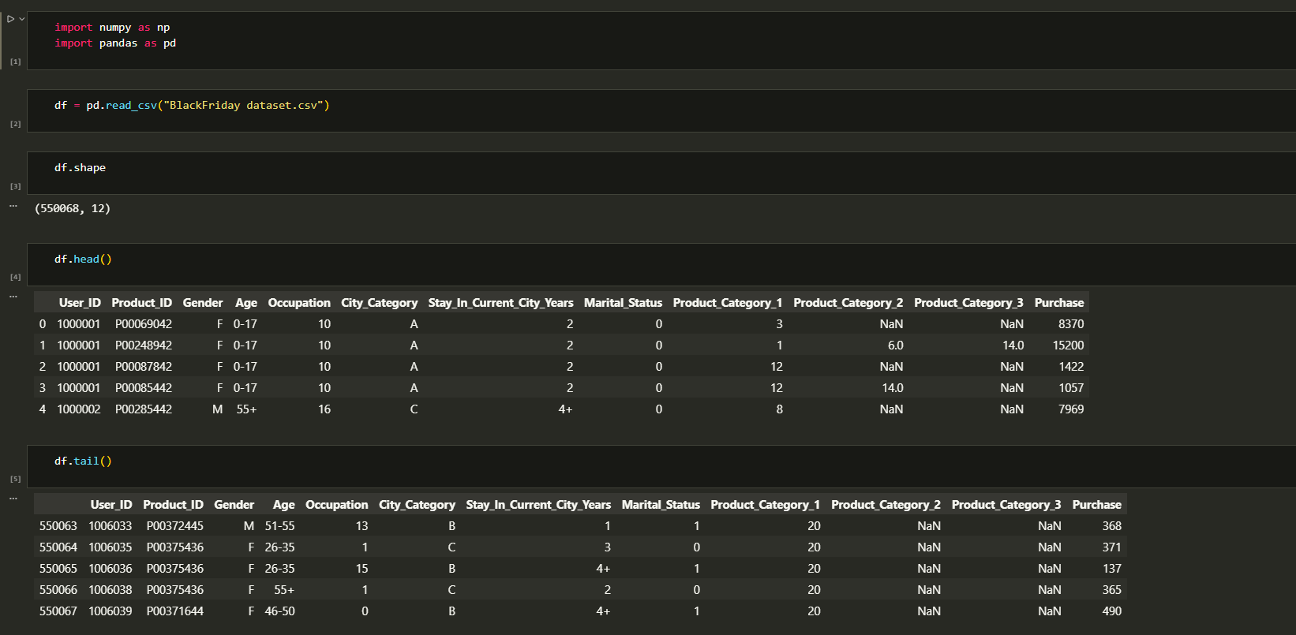
Numpy implementation
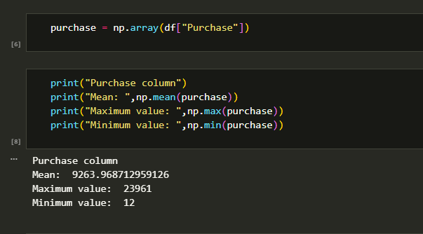
Team Contributions:
24BAD004 K ADHITHYA – Numpy implementation
24BAD005 AJAIKUMAR M - Studied features and identified important columns
24BAD027 Gowri Shankar J - Loaded the dataset and checked basic details
24BAD043 Jaya Rethanya K K – Pandas implementation

Error
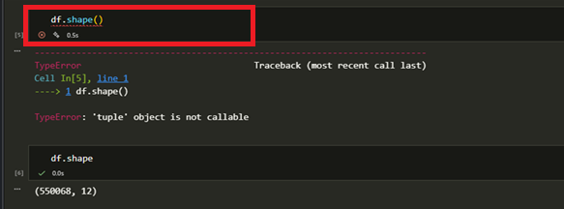
References:
1.Kaggle
https://www.kaggle.com/datasets/sdolezel/black-friday
2. Pandas
https://www.w3schools.com/python/pandas/pandas_csv.asp
3. Numpy
https://www.w3schools.com/python/numpy/numpy_creating_arrays.asp
Week 2

Activity / Milestone
During this week, we loaded the dataset into Python using Pandas and started exploring it. We checked the structure of the data by looking at column names, data types, and summary statistics. We identified missing values and understood the overall quality of the dataset. A simple first-impression report was prepared based on our observations. This helped us become familiar with the data before cleaning it.
GitHub Link: https://github.com/adhithya123456433/24AD204_DSV_Team12.git
Code and Screenshots:

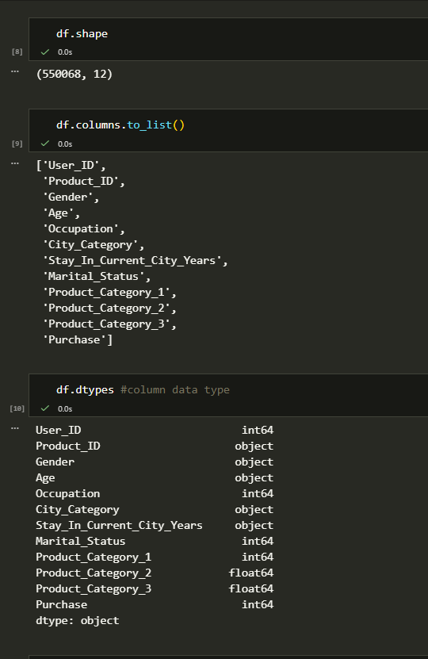

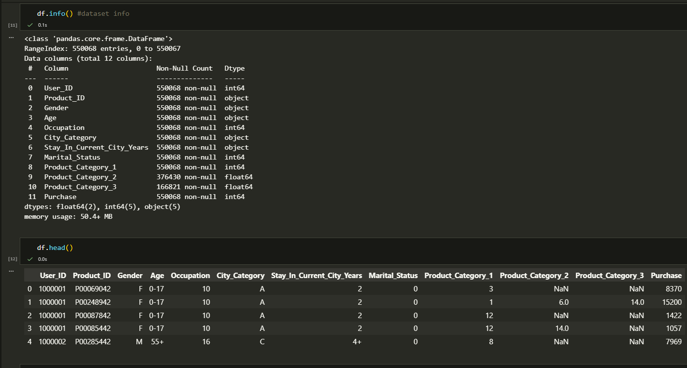
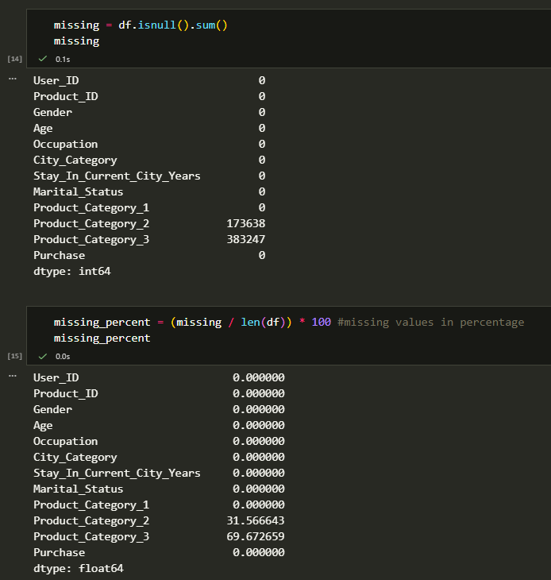
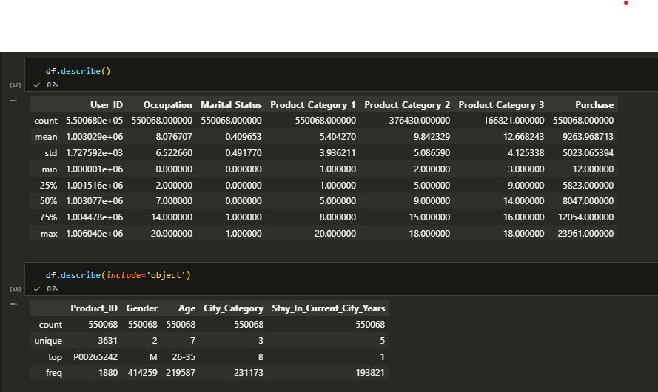
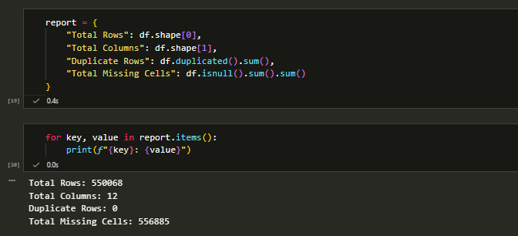
error
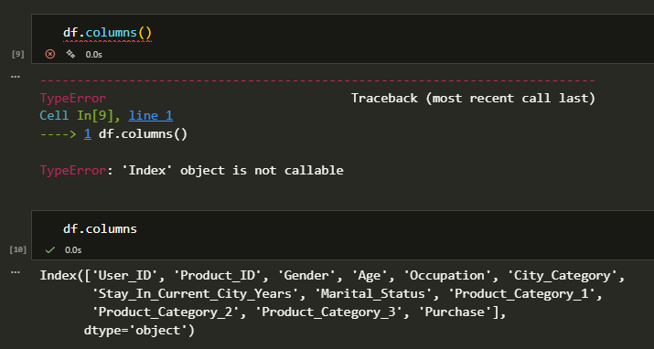

Team Contributions:
24BAD004 K ADHITHYA – Identified missing values and duplicates.
24BAD005 AJAIKUMAR M - Prepared first impression report and documentation.
24BAD027 Gowri Shankar J - Loaded dataset and checked structure.
24BAD043 Jaya Rethanya K K – Analyzed data types and summary statistics.

References:
1. Pandas
https://www.w3schools.com/python/pandas/pandas_csv.asp

Week 3
Activity / Milestone
This week we focused on cleaning the dataset to prepare it for analysis. We handled missing values using suitable replacement methods for numerical and categorical data. We checked for outliers using boxplots to observe extreme purchase values. Since higher purchases are normal during Black Friday sales, we did not remove the outliers and kept them for analysis. After completing cleaning, we verified the dataset and prepared it for further exploration.
GitHub Link: https://github.com/adhithya123456433/24AD204_DSV_Team12.git
Code and Screenshots:
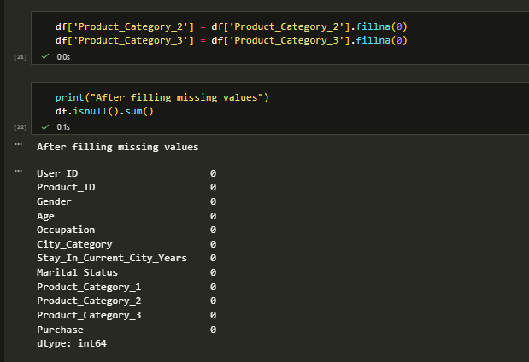
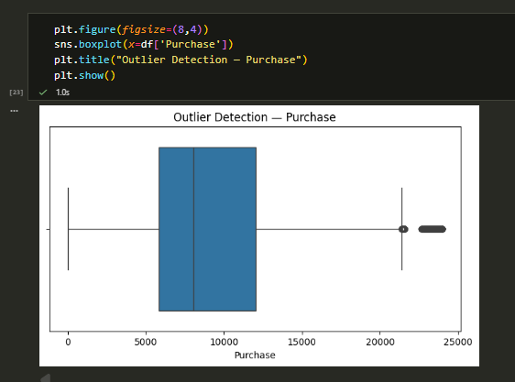
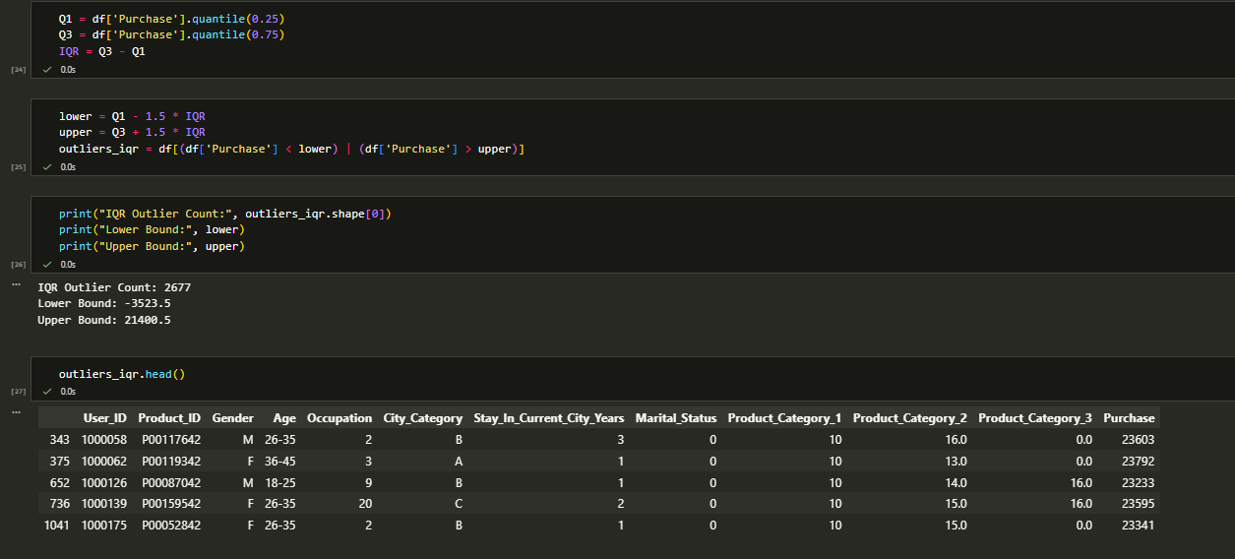
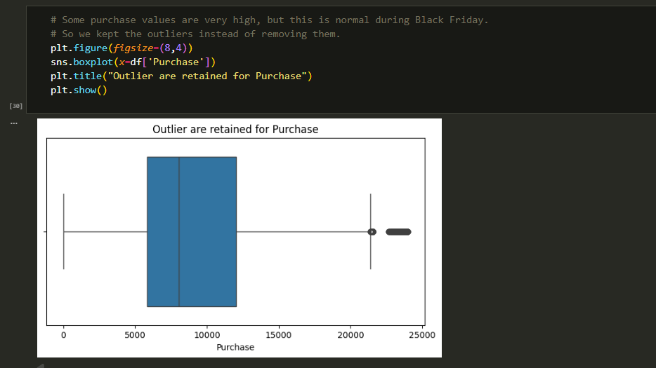

Error
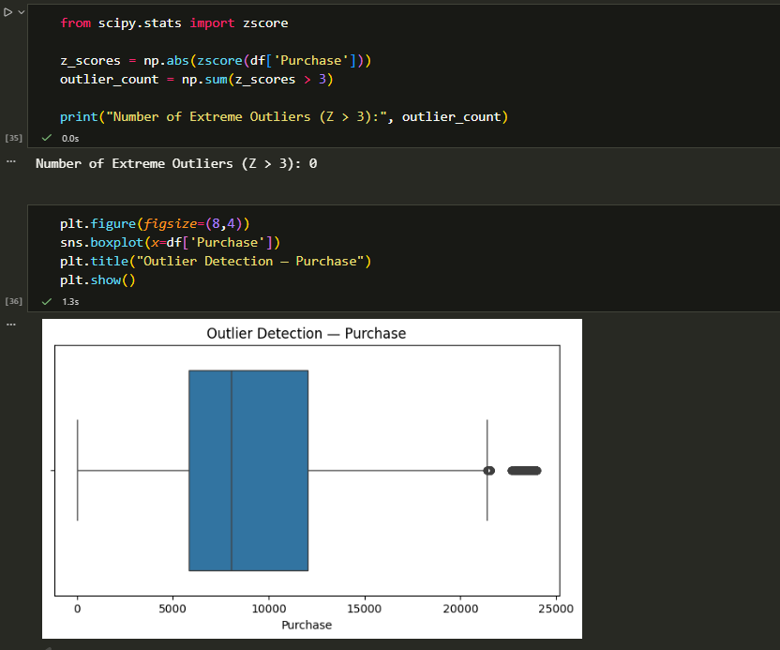
Team Contributions:
24BAD004 K ADHITHYA – Handled missing values
24BAD005 AJAIKUMAR M – Performed IQR outlier detection.
24BAD027 Gowri Sankar J - Created boxplots for outlier visualization
24BAD043 Jaya Rethanya K K – Analyzed whether to remove outliers. Prepared documentation and summary

References:
1. Pandas
https://www.w3schools.com/python/pandas/pandas_csv.asp

2. Matplotlib
https://www.geeksforgeeks.org/data-visualization/box-plot-in-python-using-matplotlib/

Week 4

Activity / Milestone
In this week, we performed exploratory data analysis to understand patterns in the dataset. We carried out univariate analysis to study individual variables and their distributions. Bivariate analysis was done to see relationships between different features. We created graphs and visualizations to better understand customer behavior and purchase trends. This helped us gain useful insights for further interpretation.
Github Link:
https://github.com/adhithya123456433/24AD204_DSV_Team12.git

Code:
4.1 — Who is Shopping? Gender Split
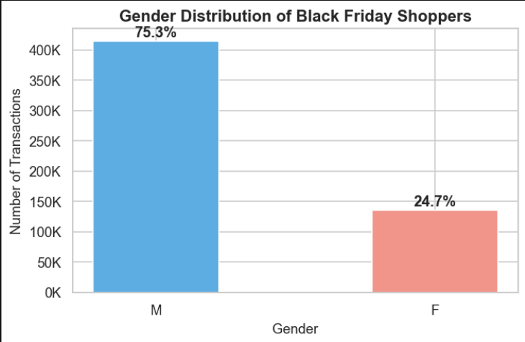

What the graph shows:75 % of all Black Friday transactions come from male shoppers. Female shoppers account for only 25 %.
Logistics insight: Products popular with men — electronics, gadgets, sports equipment — will dominate order volume. These product zones need the most picking staff, the most floor space, and the fastest restock alerts on Black Friday.

4.2 — Which Age Group Shops the Most?

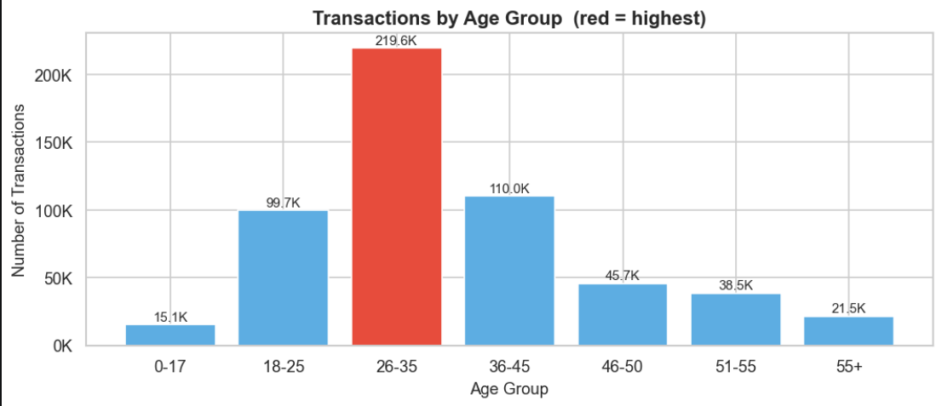

What the graph shows: The 26–35 age group has the most transactions by a large margin, followed by 18–25 and 36–45.

Logistics insight: The 26–35 group is in their peak earning and spending years. Whatever they buy most frequently needs the highest stock levels. Warehouse picking lanes for those product categories need the fastest throughput on Black Friday.

4.3 — Which City Tier Generates the Most Orders?

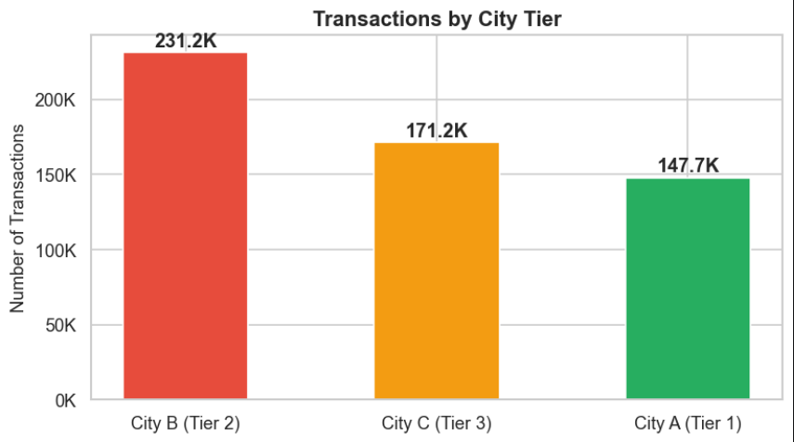

What the graph shows: City B (Tier-2 cities) generates the most orders — more than City A and City C combined.
Logistics insight: The distribution centre serving Tier-2 cities faces the heaviest Black Friday load. It needs the most workers, the most stock, and the most delivery vehicles. City A and City C warehouses need far less capacity.

4.4 — Which Product Categories Sell the Most?
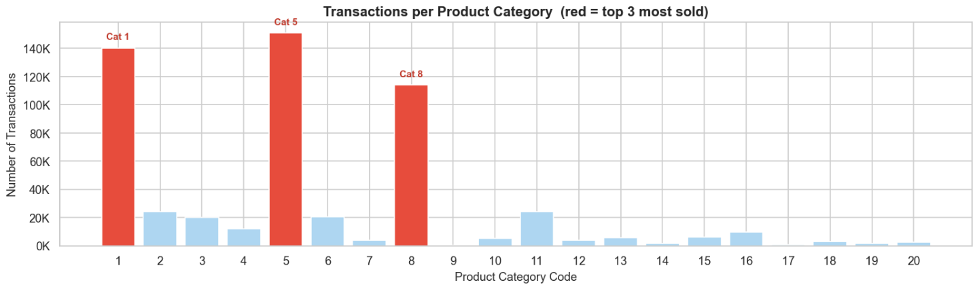
What the graph shows: A small number of product categories account for the vast majority of transactions. These top 3 categories (in red) are by far the busiest.
Logistics insight: These categories are the hottest zones in the warehouse on Black Friday. They need the fastest staff, the most floor space, and automatic restock alerts when inventory runs low.
4.5 — How Much Do Customers Spend?

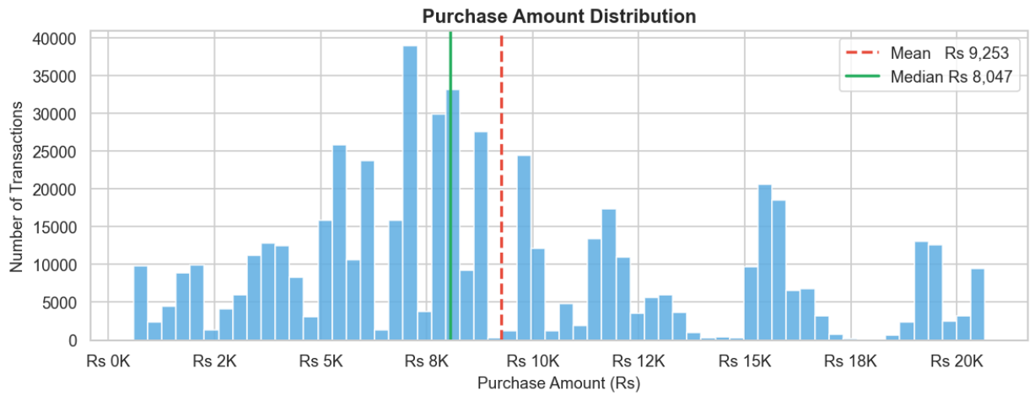

What the graph shows: Most transactions cluster between Rs 5,000 and Rs 12,000. The mean is higher than the median (right-skewed) — a smaller group of customers spends much more than average.
Logistics insight: We cannot plan a single fulfilment process for all orders. High-spend orders are heavier and more valuable — they need a dedicated express lane with faster handling, priority dispatch, and premium packaging.

Skewness value = 0.57
4.6 — Do Men and Women Spend Differently?

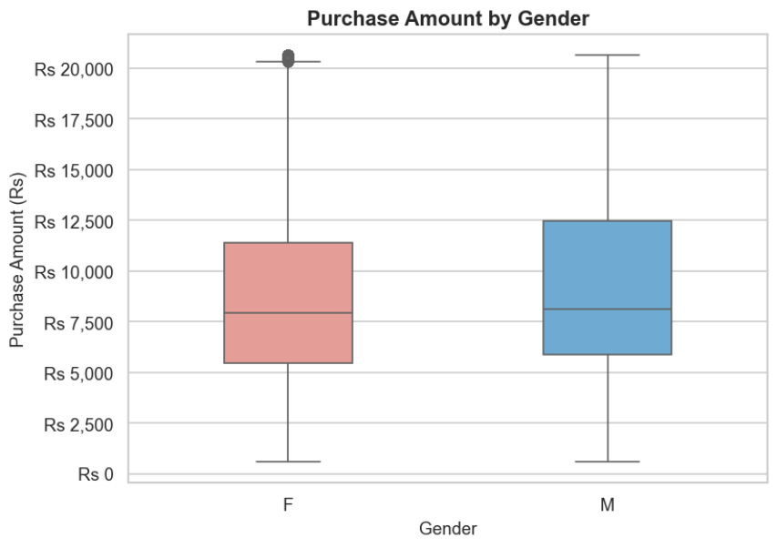

What the graph shows: Male shoppers spend slightly more per transaction than female shoppers. The median and interquartile range are both marginally higher for men.
Logistics insight:Male-targeted product zones carry both higher volume AND higher spend per shipment — heavier items, bigger boxes, higher priority for restock on Black Friday.

4.7 — Does City Tier Affect How Much People Spend?

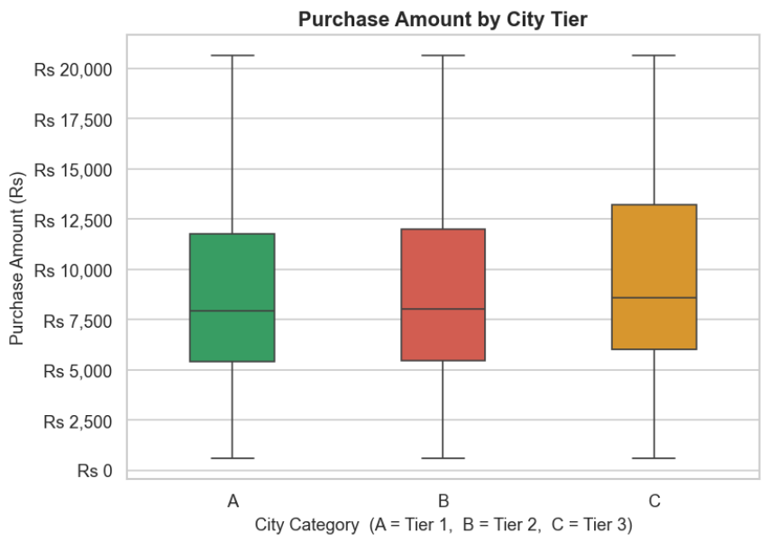

What the graph shows: City C (Tier-3, smaller cities) has the highest median purchase per order, even though it has fewer total transactions than City B.
Logistics insight: Tier-3 city shoppers place fewer orders but spend more per order. Warehouses serving City C should stock more premium, higher-priced products — even though their total shipment volume is lower.

4.8 — Which City-Gender Combination Drives the Most Volume?

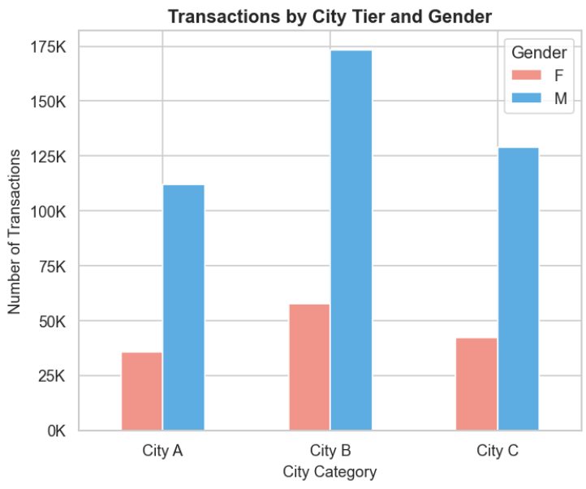

What the graph shows: City B + Male is the single largest city-gender combination by a wide margin.
Logistics insight: The City B warehouse — specifically the male product zone — is the biggest bottleneck on Black Friday. This zone needs the most staff, the fastest conveyor belts, and the highest restock frequency of any zone in the entire operation.

4.9 — Which Categories Generate the Most Revenue?

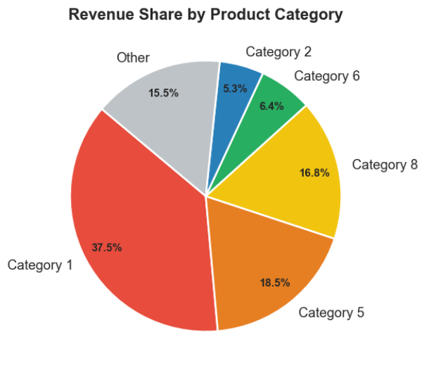

What the graph shows: Just 5 product categories generate the majority of total Black Friday revenue.
Logistics insight: If these top-revenue categories run out of stock or get delayed, revenue is lost immediately. These zones need the most warehouse floor space, the highest stock levels, and the fastest processing speed on Black Friday.

4.10 — Which Age Group Spends the Most Per Order?

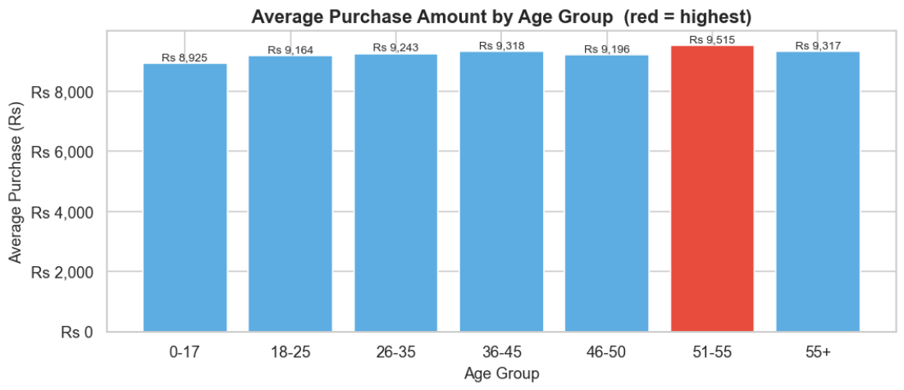

What the graph shows: Older age groups (55+) have the highest average spend per transaction, even though they buy less frequently.
Logistics insight: Premium and high-end products need priority pick zones to serve the high-spending older customer segment — even if they represent a smaller share of total volume.

4.11 — How Do All Variables Relate to Each Other?

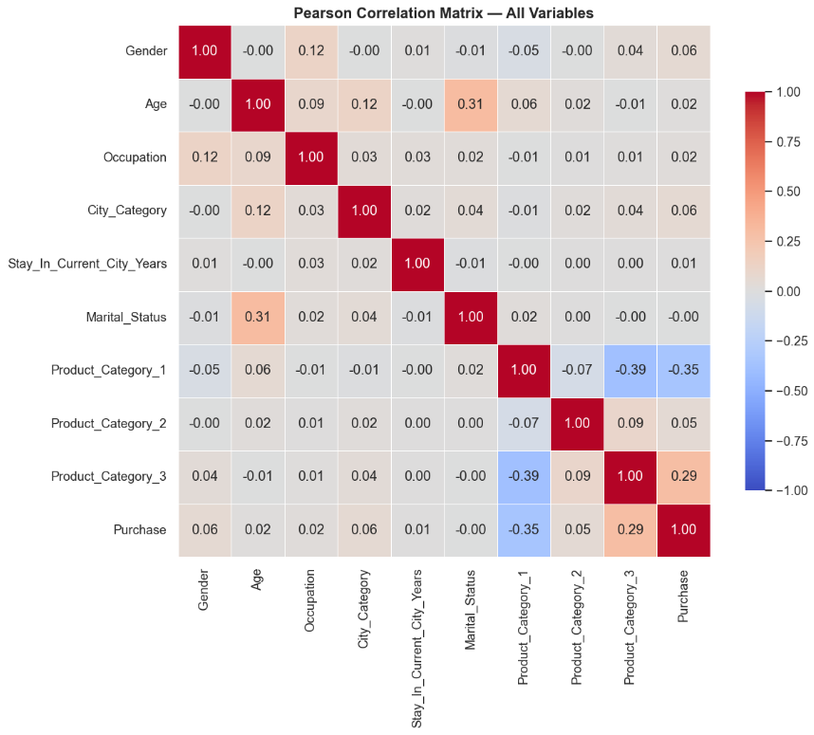
What the graph shows: `Product_Category_1` has a moderate negative correlation with `Purchase` — lower category numbers are more expensive products. `Product_Category_2` and `_3` are positively correlated — they frequently appear together in the same order. Demographics like Gender and Age have weak individual correlations with Purchase.
Logistics insight: No single column strongly predicts spend on its own — we need to combine them. Products in Category 2 and 3 are bought together, so a bundle-picking station for these two would speed up warehouse packing significantly.

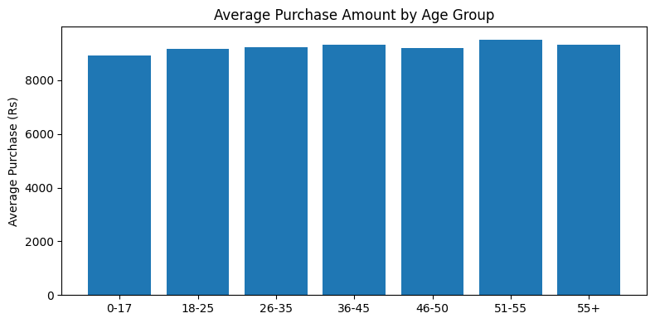
The 55+ age group has the highest average spend per transaction.
Logistics insight:
Older shoppers spend more per trip even though they buy less frequently.
Premium and high-end products need priority pick zones to serve this segment well.

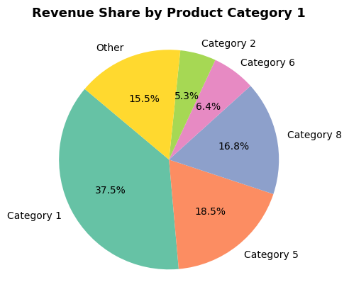
A small number of product categories generate most of the total revenue.

Logistics insight:
These top categories are responsible for the majority of Black Friday income.
They need the most warehouse floor space, the most stock, and the fastest processing.
If these zones run out of stock or slow down, it directly impacts the store's revenue.

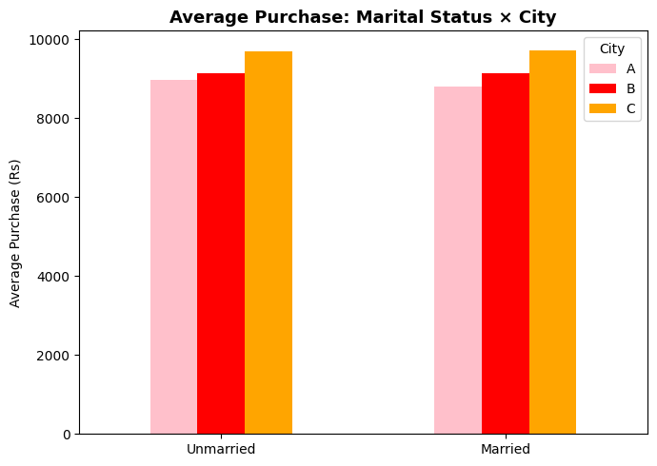Unmarried shoppers in City C spend the most on average across all combinations.
Logistics insight:
Tier-3 city warehouses should allocate more premium product stock
particularly for single-buyer customer segments.

WEEK 6 – Feature engineering
6.2 — Fixing Purchase Skewness
# ── Plot 1: Before Yeo-Johnson Transformation ─────────────────────────────
fig1, ax1 = plt.subplots(figsize=(8, 4))
sns.histplot(df_eng['Purchase'], bins=60, kde=True,
color='#E76F51', edgecolor='white', alpha=0.85, ax=ax1)
ax1.set_title(f'Before Transform (Skew = {df_eng["Purchase"].skew():.2f})')
ax1.set_xlabel('Purchase Amount (Rs)')
ax1.set_ylabel('Frequency')
plt.tight_layout()
plt.show()

# ── Plot 2: After Yeo-Johnson Transformation ──────────────────────────────
fig2, ax2 = plt.subplots(figsize=(8, 4))
sns.histplot(df_eng['Purchase_yj'], bins=60, kde=True,
color="#1B4F8A", edgecolor='white', alpha=0.85, ax=ax2)
ax2.set_title(f'After Yeo-Johnson (Skew = {df_eng["Purchase_yj"].skew():.2f})')
ax2.set_xlabel('Transformed Purchase')
ax2.set_ylabel('Frequency')
plt.tight_layout()
plt.show()

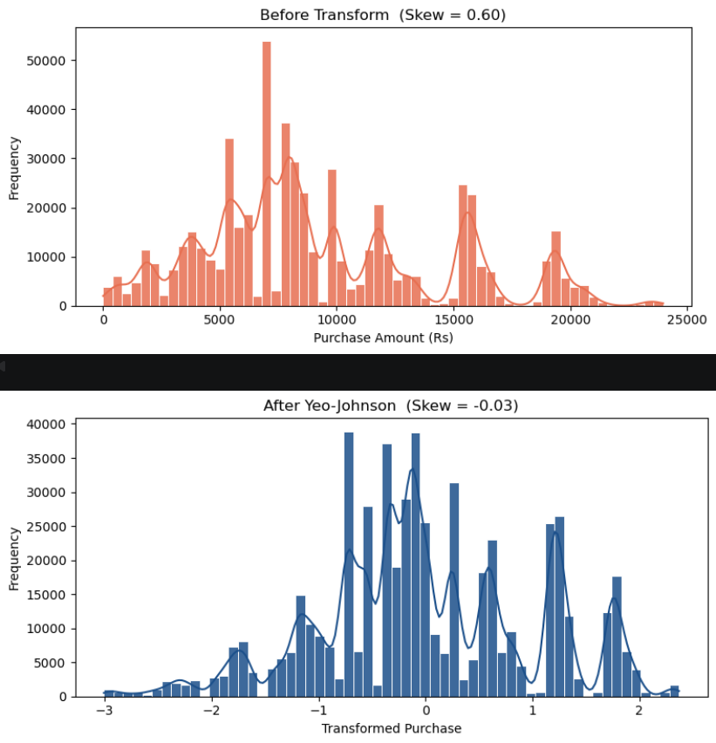

Before the transformation, the distribution has a long right tail — classic right skew. After Yeo-Johnson, the distribution is nearly symmetric and bell-shaped. The skewness has dropped from around 0.59 toward 0.
This matters for logistics forecasting: a symmetric distribution gives models a better baseline prediction of "typical" spend, which leads to more accurate demand estimates and fewer stock-out or over-order situations on Black Friday.

6.3 — Feature Engineering: 7 New Logistics-Relevant Features
Feature 1: category_depth
df_eng['category_depth'] = (
(df_eng['Product_Category_1'] > 0).astype(int) +
(df_eng['Product_Category_2'] > 0).astype(int) +
(df_eng['Product_Category_3'] > 0).astype(int)
)

Feature 2: is_high_value
df_eng['is_high_value'] = (df_eng['Purchase'] >= df_eng['Purchase'].quantile(0.80)).astype(int)

Feature 3: is_new_resident
df_eng['is_new_resident'] = df_eng['Stay_enc'].isin([0, 1]).astype(int)

Feature 4: is_young_male
df_eng['is_young_male'] = ((df_eng['Age_enc'].isin([1, 2])) & (df_eng['Gender_enc'] == 1)).astype(int)

Feature 5: spend_per_category
df_eng['spend_per_category'] = df_eng['Purchase'] / df_eng['category_depth']

Feature 6: product_bundle_flag
df_eng['product_bundle_flag'] = (df_eng['category_depth'] >= 2).astype(int)

Feature 7: repeat_buyer_score
df_eng['repeat_buyer_score'] = df_eng['Age_enc'] * df_eng['Stay_enc']

6.4 — Visualising the New Features
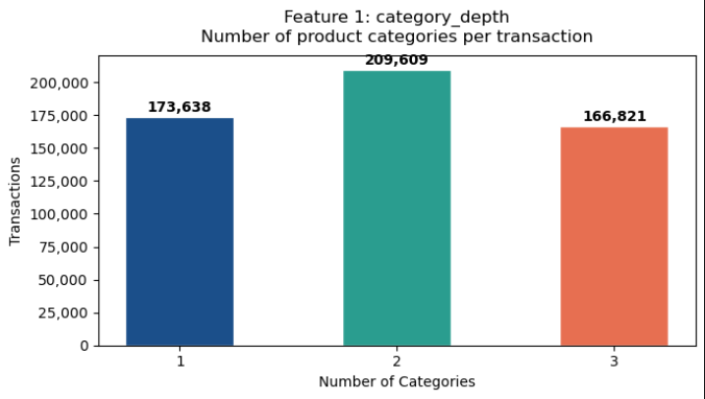

Insight — category_depth:

The overwhelming majority of Black Friday transactions are **depth-1** (single category) — meaning customers mostly buy one type of product per order. Depth-2 and depth-3 orders are a significant but smaller minority.

Logistics implication: Most orders can be fulfilled from a single warehouse zone — a simple pick-pack-ship flow. However, the depth-2 and depth-3 bundle orders require multi-zone picking and careful consolidation. Without a dedicated bundling lane, these orders are the primary source of packing delays and split-delivery errors on Black Friday.

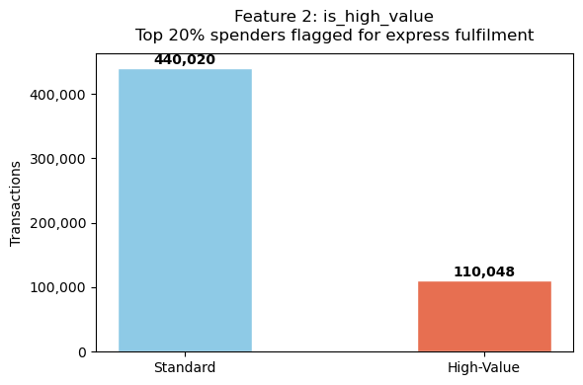

Insight — is_high_value:

Exactly 20% of transactions are flagged as high-value (by design — the 80th percentile cutoff). While this is a minority of orders, they carry disproportionate revenue weight — losing even a small fraction of these orders to packing errors or delays has an outsized financial impact.

Logistics implication: High-value orders should be automatically routed to an express fulfilment lane with enhanced packaging standards, signature-required delivery scheduling, and priority dispatch. A separate quality-check station for these orders avoids mixing them with the standard mid-range flow and reduces the risk of mispacking premium items.

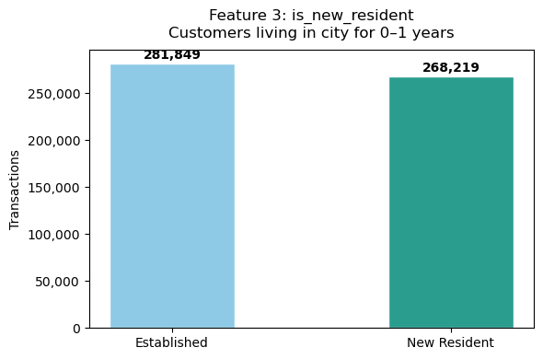

Insight — is_new_resident:

Roughly half of all transactions come from new residents (0–1 years in city). This is a strikingly large share — nearly as many new-city customers as long-established ones are shopping on Black Friday.

Logistics implication: New residents are setting up their homes — they are far more likely to purchase large, bulky items like appliances, furniture, and home electronics. These orders need **larger packaging, heavy-duty delivery vehicles, and morning delivery windows** (when new residents are more likely to be home). Warehouses should pre-position large-capacity trucks and extra packing materials for oversized items on Black Friday morning.

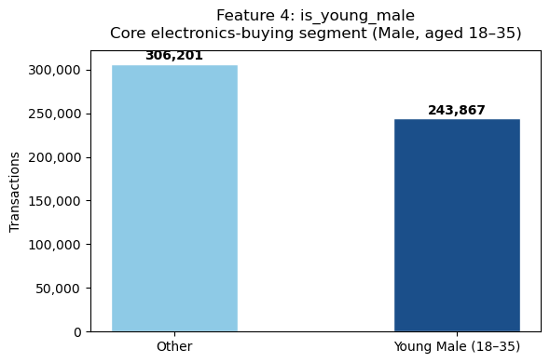

Insight — is_young_male:
Approximately 43% of all transactions come from the young male (18–35) segment. This is the single dominant buyer group — nearly half the entire Black Friday order flow comes from this one demographic.

Logistics implication: This segment concentrates heavily in electronics, gadgets, and tech accessories — all requiring specific packaging (anti-static, foam inserts), voltage checks, and warranty-sticker placement. Pre-staging additional picking carts, opening extra packing stations, and alerting the electronics restocking crew first is the highest-leverage single intervention a warehouse manager can make before Black Friday begins.

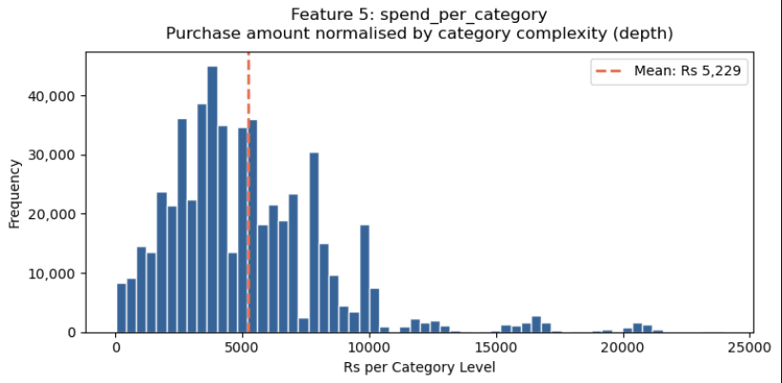

Insight — spend_per_category:

The distribution is right-skewed, similar to the raw Purchase distribution. The mean spend per category level sits around Rs 9,000. There is a visible long tail of very high per-category spenders — these are customers buying expensive single-category items (e.g., a premium laptop or a high-end appliance).

Logistics implication: A high `spend_per_category` on a depth-1 order signals a premium single item — treat it with extra care, superior packaging, and insurance-grade handling. A low `spend_per_category` on a depth-3 order signals three small, low-cost items that are still logistically demanding due to multi-zone picking requirements. This feature helps warehouse systems triage orders by handling complexity vs. value, ensuring the right level of attention is applied to each.

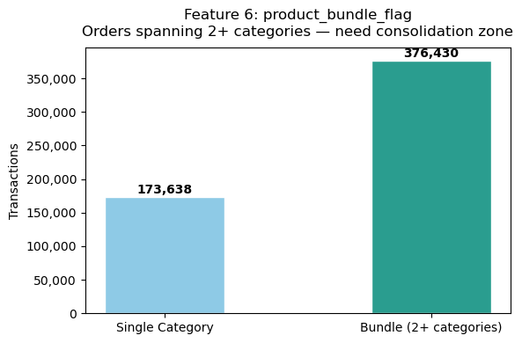
Insight — product_bundle_flag:

About 46% of all transactions are bundle orders (2+ product categories). This is remarkably high — almost half of every order on Black Friday involves multiple picking zones in the warehouse.

Logistics implication: Without this flag, warehouse systems can accidentally route the sub-items of a bundle to separate shipping stations, generating split deliveries — one of the leading causes of incomplete-order returns. `product_bundle_flag` can directly trigger a bundle-assembly workflow that routes multi-category orders to a dedicated consolidation zone before they enter the packing queue, dramatically reducing the rate of partial-shipment errors.

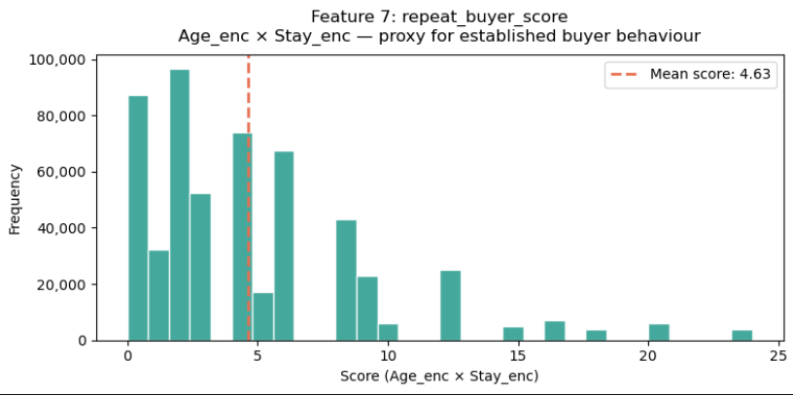

Insight — repeat_buyer_score:

The distribution is heavily concentrated at 0 — meaning the majority of transactions come from young customers or those who are new to their city (both of whom produce a score of 0 since `Age_enc × Stay_enc = 0` when Stay = 0). There is a long right tail of higher scores representing older, long-established residents with predictable purchasing habits.

Logistics implication: Customers with high repeat_buyer_score have predictable, repeatable purchasing patterns — their preferred product zones can be pre-stocked from historical data before Black Friday opens, reducing the risk of stockouts in their key categories. Score-0 customers are exploratory and unpredictable — their zones need broader stock variety and more flexible replenishment triggers to handle the wider range of products they might demand.

Week 7 — Dimensionality Reduction

7.1 — Correlation Heatmap (Filter Method)
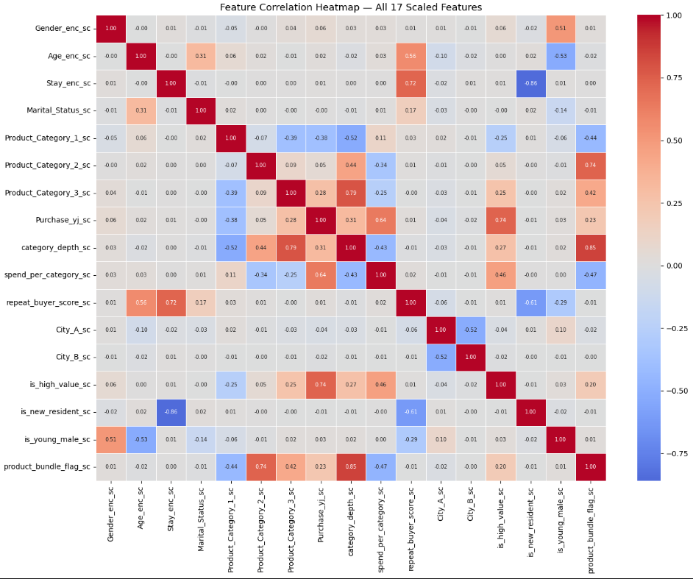

The heatmap reveals several highly correlated feature pairs. The most notable ones are:

- `is_high_value_sc` is strongly correlated with `Purchase_yj_sc` since high-value customers are defined by their purchase amount.
- `spend_per_category_sc` is closely linked to `Purchase_yj_sc` for similar reasons — both are derived from the Purchase column.
- `product_bundle_flag_sc` and `category_depth_sc` are naturally correlated since bundles always have deeper category depth.

We will use these observations to guide which features to drop.

Drop decision: `product_bundle_flag_sc` is dropped because it has a measured pairwise correlation of 0.853 with `category_depth_sc` (above the 0.80 threshold). `is_high_value_sc` and `spend_per_category_sc` are dropped on logical/definitional grounds — both are directly derived from the `Purchase` column, making them conceptually collinear with `Purchase_yj_sc` even if their pairwise r did not breach 0.80 in isolation. These three drops are therefore a combination of the statistical filter and explicit feature-derivation reasoning.

7.3 — VIF Score Bar Chart
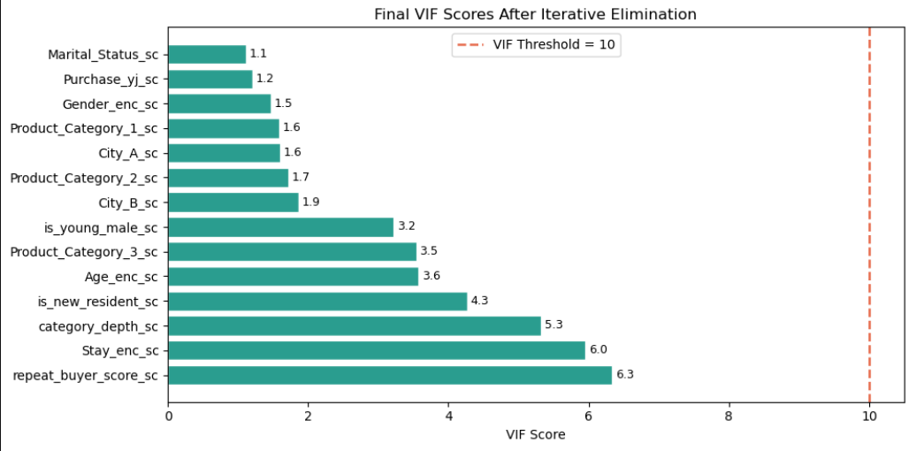

Every remaining feature scores well below the red threshold line at VIF = 10. The features are now mathematically independent enough to serve as clean inputs for PCA.

7.5 — Feature Variance Bar Chart
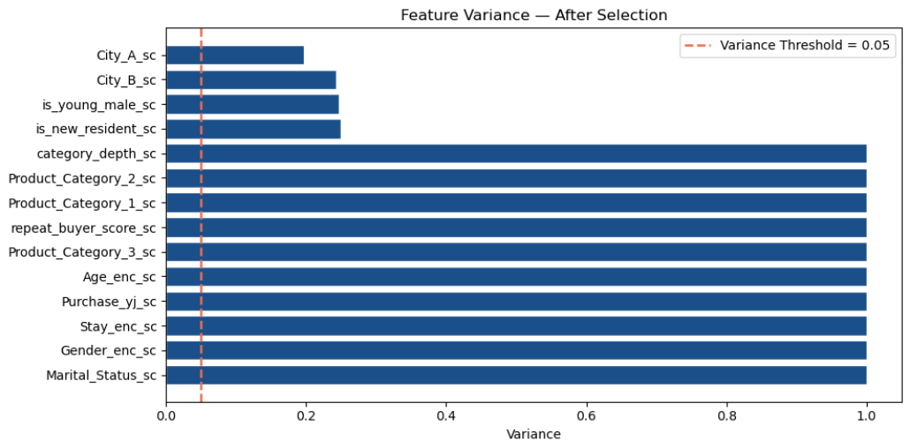
All features comfortably exceed the minimum variance threshold. The features are evenly distributed in terms of variance, with no single feature dominating or being nearly constant.

7.8 — Scree Plot
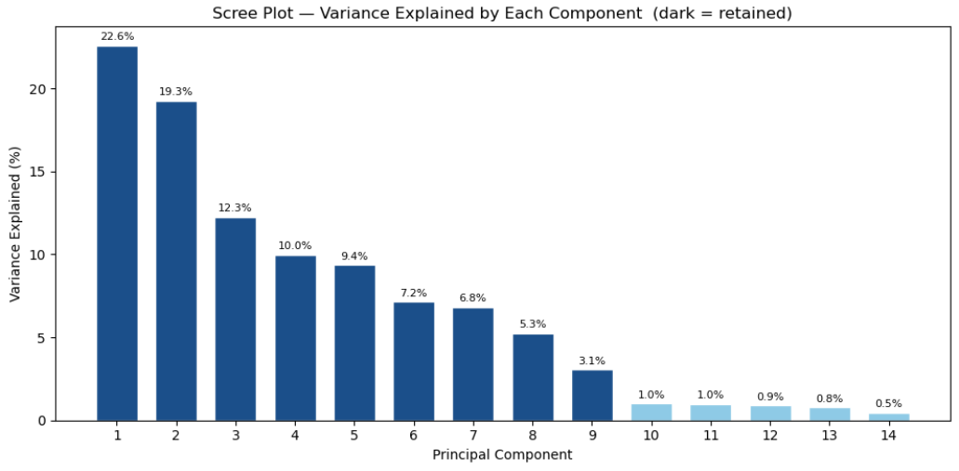
The Scree Plot shows how much variance each principal component explains individually. The **dark blue bars** are the components we retain (those needed to reach 95% cumulative variance). The light blue bars are the discarded components — together they contribute less than 5% of the total information.

PC1 carries the largest single share of variance, and each subsequent component carries progressively less. This is the expected "elbow" pattern in a well-formed PCA.
7.9 — Cumulative Variance Curve
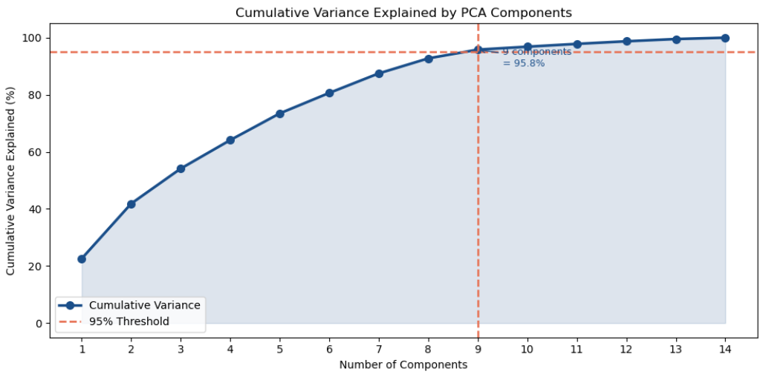

The cumulative variance curve shows how quickly the principal components accumulate explanatory power. The curve rises steeply for the first few components, then flattens — confirming that diminishing returns set in quickly and we do not need many components to capture most of the information.

The red dashed lines mark the 95% threshold and the exact number of components needed to cross it. Beyond that point, each additional component adds very little new information.

7.11 — Feature Loading Heatmap
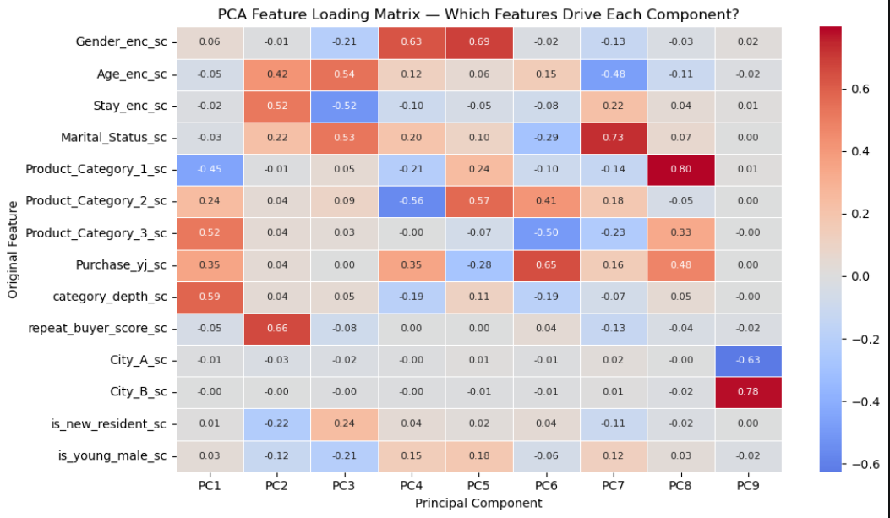

The loading heatmap shows how much each original feature contributes to each principal component. **Darker blue** means a stronger positive contribution. Near-zero values (close to white) mean the feature has little influence on that component.
By reading down each column we can name each PC based on its dominant drivers:

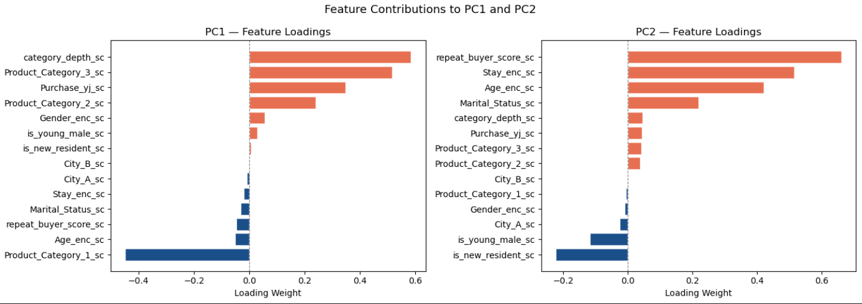
PC1 — "The Purchase Power Signal" is dominated by purchase-related features (`Purchase_yj_sc` and derived spend features). The positive loadings on the right represent high-spend transactions. This is the single most powerful predictor of transaction size across the entire dataset.

PC2 — "The Demographic Profile" shows a clear split between demographic signals. `Gender_enc_sc` and `is_young_male_sc` load positively, while `repeat_buyer_score_sc` and `Age_enc_sc` pull in the opposite direction — separating the exploratory young male segment from established older buyers. Logistics teams can use this PC to anticipate demand surges in electronics vs. home goods zones.

7.13 — PCA 2D Scatter Plot
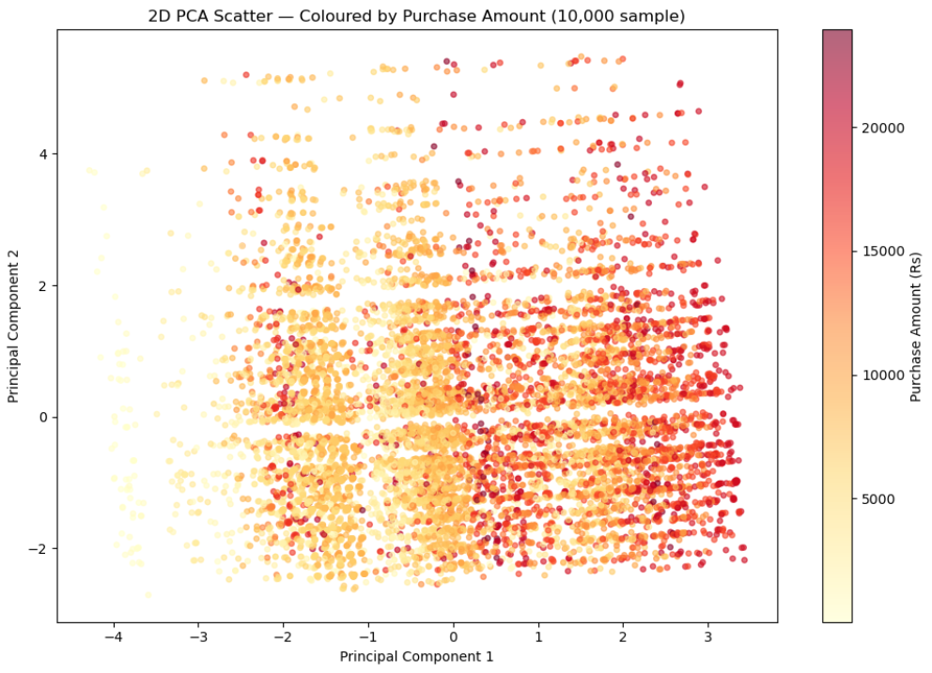

The scatter plot projects a random sample of 10,000 transactions (from the full 550,068) onto the plane defined by PC1 and PC2. A sample is used here for plotting performance — the PCA transform itself was computed on all rows.
The cloud shape reveals the underlying structure of the data — transactions are not randomly distributed but form a structured, elongated cloud with visible density gradients.
The concentration of points in the centre represents the "typical" Black Friday transaction — a mid-range purchase of a common product by an average customer. Points at the edges represent unusual combinations: a very old customer buying a multi-category bundle, or a new resident purchasing a premium single item.
Note that PC1 and PC2 together explain only a fraction of the total variance. Significant structure exists in the remaining components as well — which is why we retain multiple PCs rather than just two.
7.14 — Variance Explained per Component (Detail)
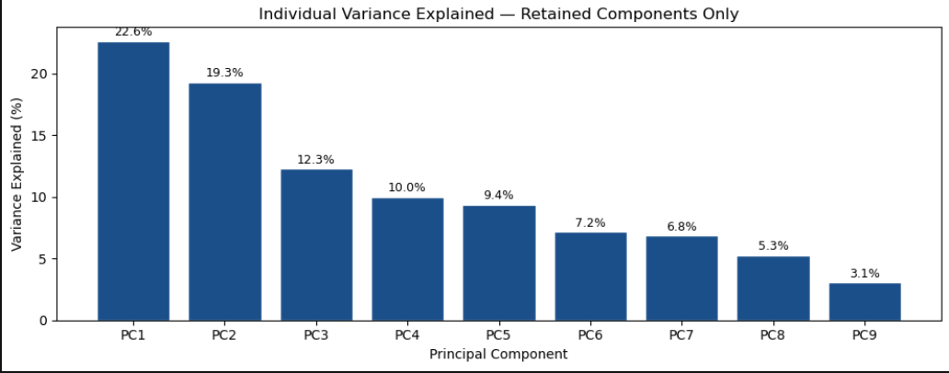

This chart shows only the retained components (those that together explain 95%+ of variance). We can see the relative contribution of each retained PC. Earlier components carry more information; later ones carry less but are still above the threshold where dropping them would lose meaningful signal.

Team Contributions:
Bivariate analysis performed by:
24BAD004 K ADHITHYA
24BAD005 AJAIKUMAR M

Univariate analysis performed by:
24BAD027 Gowri Sankar J
24BAD043 Jaya Rethanya K K

References:
1. Pandas
https://www.w3schools.com/python/pandas/pandas_csv.asp

2. Matplotlib
https://www.geeksforgeeks.org/pandas/bar-plot-in-matplotlib/

3. seaborn
https://www.geeksforgeeks.org/python/countplot-using-seaborn-in-python/

